

SalesForce - Quick Tips and Best Practices
Step-by-Step How to Guide

Creating Custom Views

Best Practice: How to Create a Custom Screenview for the Programs tab, sorting all current and active program templates alphabetically by ensemble name. This gives you a succinct list of all of your artists’ programs, without having to sort through years’ worth of Contract Program copies, old programs, former artists, etc.

Program tab / click – Create New View

1 Enter View Name
SF will create the “Unique” name

2 Specify Filter Criteria
Filter by Owner – select All Opportunities
Filter by Additional Fields – Active equals True; Fiscal Year equals 2015 (or other year); Record Type equals Program Template

3 Select Fields to Display
Highlight desired fields under “Available Fields” – Artist; Program Name; Art Form (General); Grades; Record Type. Then click arrow to the right; fields will appear under “Selected Fields” in alpha order.
Use the up/down arrow buttons to set the order in which those fields will appear

4 – Restrict Visibility
Determine who can see this view: you alone, all your users, or specific User Groups

SAVE

Your new view will appear in the drop down list on the Programs tab, select and click Go.

Creating Custom Fields

Create a New Custom Field
Setup > Build > Customize > Opportunities > Fields
Opportunity Custom Fields & Relationships > Click New
1 Choose the Field Type > Click Checkbox > Click Next

2 Enter the Details
Type in Field Label; SalesForce will create the Field Name
Determine whether default value is checked or blank

3 Establish Field level Security
Determine which of your users get to see and/or edit the checkbox

4 Add to Page Layouts
Determine where this new field will appear

Adding a new field into an existing report
Setup > Create > Report Types
Click on desired Report Type - Opps with Programs, Components, Dates
Click Edit Layout button
Select section to view (box to the right of the big grid)
Click on the new field just created > drag it into the appropriate section on the left grid
CLICK SAVE

Reports
Select the report you want to add that field to
Click the Customize button
New field should now appear in the list to the left – drag it into the report body where you want it (look for the green checkmark before letting go of the drag)

Be sure to save your newly customized report!

Creating Custom Reports

Best Practice: Create an Opportunity Pipeline Report to be sent to your email once a week to monitor program bookings in queue and ensure timely closure. This Report is ideal for a Program Coordinator/Manager/Director to help keep track of inquiries that have not yet been officially contracted and details are needed for completion.

1. Go to ReportsNew Reports

2. Select OpportunitiesOpportunitiesOpps with Programs, Components, Dates

3. Add the following filters:
- Do Not Show on Calendar equals False
- Stage equals Inquiry, Needs Analysis, Proposal/Price Quote
  - These may be different by chapter; essentially, select any stage underneath “Contract Sent.” These are the bookings still in queue.
- Cancelled equals False

4. Reformat as needed to reflect details needed for contract completion. For instance, my columns include:
- Date
- Timeframe
- Artist: Account Name
- Program Name
- Grades
- Attendees
- Account Name: Account Name
- Venue: Account Name
- Venue: Shipping Address
- Account Name: Shipping Address
- Account Name: Phone

5. Save your Report as “Pipeline Report.”

6. Click on your Report. Click the arrow next to Run Report and select “Schedule Future Runs.”

7. Select the Email recipient(s), Frequency, and time for the report to be run. It will arrive in the designated inbox as scheduled, and you can crosscheck it for missing details!

Creating Dashboards

Best Practice: If you have a grouping of reports you look at frequently, put them all in view using Dashboards. YAMD uses this feature to track retention in each county as well as track number of program bookings by type. Dashboards use graphs to provide visuals on your progress, and use real time updates based on the data in Salesforce.

Part A – Create Your Reports
Either create your reports, or know which reports you would like to group together in a Dashboard.
Tip: When saving the reports, use a common naming convention to easily identify the reports you need for your Dashboard. For example, each report I’m using begins with “MSAC” because they all relate to the MSAC grant campaign our Program team manages.

Part B- Create Your Dashboard
Click on the Reports tab
Click the New Dashboard button
This page is the Dashboard Builder. On the left hand side, you will see two tabs: Components and Data Sources. To select the report(s) you’d like to view in Dashboard, click on the Data Sources tab.
Use the Quick Find search bar tool to easily search your reports. Using the Tip from above, use the common naming convention as your search word. In the example below, I used “MSAC.”
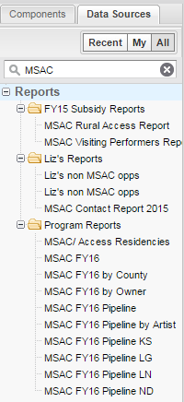
To add the report to the Dashboard builder, simply click and drag the name of the report into one of the 3 columns of the builder.
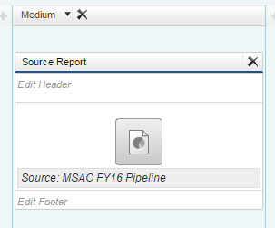
In order to actually get a visual for the data, click on the Components tab on the left hand side of the Dashboard builder. The options listed will give you a sense of the visual you can use for your data. To apply the visual to your data, just click and drag the icon onto the report you added to the Dashboard builder. To change the visual, just click and drag a different one.
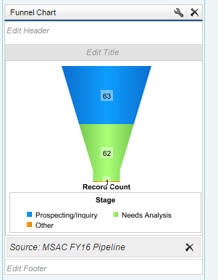
To name the report, click on Edit Header or Edit Title within the report you’ve added, and type the title.
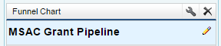
Tip: To fine-tune the data in the visual, click on the wrench icon of the graphic. This will open additional options for editing that component:
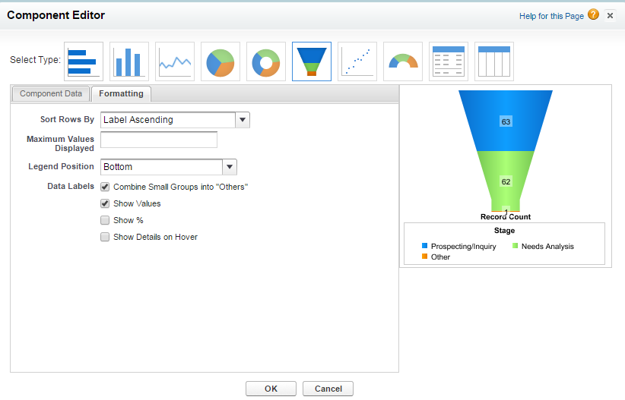
Save your report! In the top left hand side, click Save.

Name your Dashboard in the Title field. Dashboard Unique Name will auto-fill. Then, you can save your Dashboard to a particular folder. My personal Dashboard will be for your view only; Company will share it with everyone who uses your SalesForce installation. Click Save.

Keep repeating the process of adding reports until you’ve added all of those you’d like to include. Then click Close. You’ll be able to view all of your reports in one frame. To refresh the reports, just click Refresh to get the latest information.
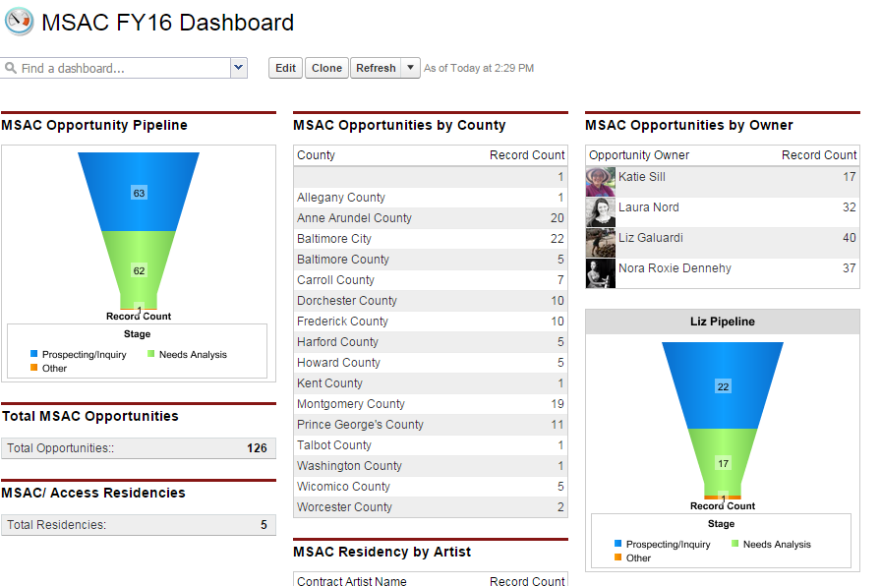

Creating Validation Rules

Best practice: Use validation rules to improve the quality of your data in Salesforce. Validation rules verify that the data a user enters in a record meets the standards you specify before the user can save the record. A validation rule can contain a formula or expression that evaluates the data in one or more fields and returns a value of “True” or “False”. Validation rules also include an error message to display to the user when the rule returns a value of “True” due to an invalid value. In this example, create a validation rule that requires the fiscal year field to not be blank when the stage of an opportunity is changed to “contracted.”

- Go to Setup
- Under the App Setup Section in the Left Navigation Bar chose your object you want to create the validation rule for. If it is a standard object (like opportunity, accounts and contacts) you will find that under customize, if it is a custom object (like Programs, Program Components, Contract Dates) you will find that under Create. In this case, we are creating a rule on the opportunity so click the arrow next to “Customize”, then click the arrow next to Opportunities.
- Then click Validation Rules.
- Click the New Button.
- Chose a Name for the Rule. I used “Fiscal Year Required on Contracted”
- Type in a description of what the rule will do.
- In the Error Condition Formula Section, you type out your formula for the validation rule (more resources to help with this are below). In this case paste in :
AND
(ISPICKVAL( StageName ,"contracted"),
ISBLANK( Fiscal_Year__c ))
- In the error message section type in what you want the error message to say if a user tries to put something into contracted but the fiscal year field is blank. I used “The fiscal year field must be filled in before the stage can be changed to contracted.”
- Choose whether you want the error message to show up at the top of the page or actually right next to the field that is blank. This is done by clicking the radio buttons next to “Error Location.”

The most complicated part of creating validation rules is writing the formula for the rule to evaluate. You are basically writing a simple statement that if that statement is true for the given record it is evaluating then the error message will be returned. In the Error Condition Formula I used above, you are basically saying that if the Stage Name is contracted and the Fiscal Year is blank to return the error.

There are many resources available on the internet about validation rules and writing the formulas. Here are a few to get you started:

https://help.salesforce.com/help/pdfs/en/salesforce_useful_validation_formulas.pdf
http://crmsuccess.blogs.com/files2/100_sample_formulas_v6.pdf

Creating Workflow Rules

Best practice: Workflow rules are Salesforce’s way of automating certain processes and tasks. You can create a rule, and based on certain criteria that you set, Salesforce can do a number of things, like send an email, create a task, or update a field. In this example: Use a work flow email to automatically and more efficiently let appropriate staff members know when an opportunity has been cancelled. We use this feature to let our finance department know as soon as possible when an opportunity has been cancelled. Everything is based on when the opportunity "stage" is changed from contracted to cancelled, this won't do anything if the stage is changed from any other stage to cancelled.

Part A) Create the Email Template

Go to Setup -> Communication Templates -> Email Templates
Click New Template
On Step 1 chose text
Chose the folder you want to save it in, make sure it is public folder
Check the available for use box
Give your Template a Name like "Opportunity Cancelled"
Then create the subject line and text you want to use, my example is below. You will want to include merge fields, which you can do by finding the field you want in the drop down boxes at the top of page and copying the "Copy Merge Field Value that it gives you in the body of the email.

Here is the text that I use (your merge field values may be different):

Hi Jan,
This email is to inform you that contact #{!Opportunity.ContractNum__c} has been cancelled by {!Opportunity.OwnerFullName}.
Here is some more information:
School/Venue Name: {!Opportunity.Account}
Artist Name: {!Opportunity.Contract_Artist_Name__c}
First Event Date: {!Opportunity.First_Performance_Date__c}
Part B) Create the Email Workflow

Go to Setup -> Create -> Workflow and Approvals -> Workflow Rules
Click New Rule
Chose the object that this rule is going to fire from (in this case the Opportunity)
Give the Rule a name and description, my name was Opportunity Cancelled Email to Finance
Chose the evaluation criteria of "created, and every time it’s edited"
Select "formula evaluates true" in the drop down menu of "Run this rule if the following":
In the text box enter the following formula:

AND(
ISPICKVAL(
PRIORVALUE(StageName), "Contracted"
),
ISPICKVAL(StageName, "Cancelled" ))

Note: If you have different stage names or have changed your field names (not common) you will need to update the formula with your specific names.

Then click next and on Step 3 click on the "Add Workflow Action" and chose "New Email Alert:"
Come up with a description "Opportunity canceled emailed to finance" is what I used
Click the magnifying glass next to email template and find the email template that you just created in Part B.
Under recipient type chose user (this will allow you to send the email to any of your salesforce users. You can also play around with this field to send to other people. Whatever you chose in the recipient type you will then get a list below of available recipients, highlight the person you want to send to and click the add arrow. You can also add emails manually in the additional emails box.

Chose the From Email Address you want the email to come from.

Then click save, then click done, then click the activate button and you should be set.

